Data Mining – Homework#2: Association Rule Mining and Time Series Analysis
Razieh Doregard – 40435056

Loading and Initial Cleaning
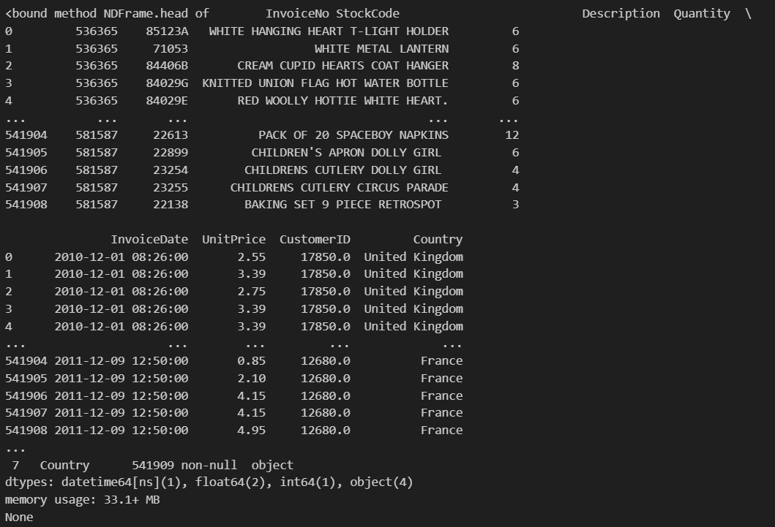

Handle Missing Values
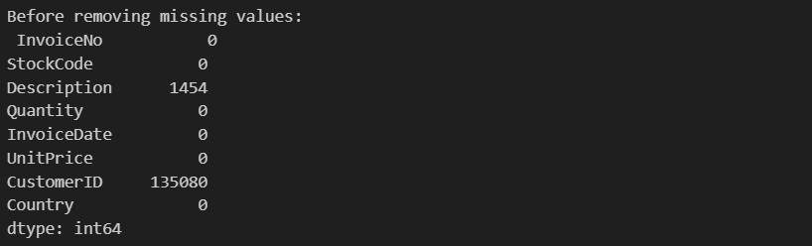

I removed all items without descriptions:
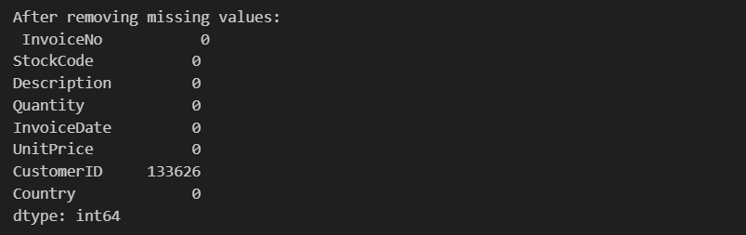
Remove invalid records
- Removed the items with invalid quantities
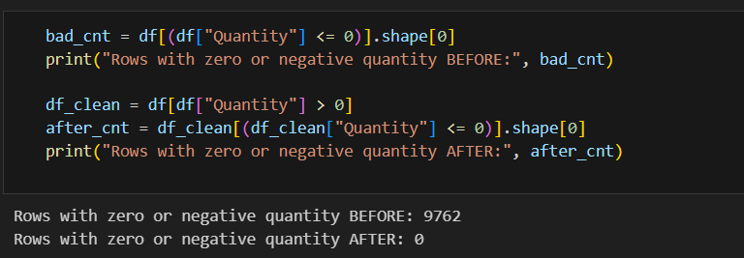
- Removed items with invalid prices
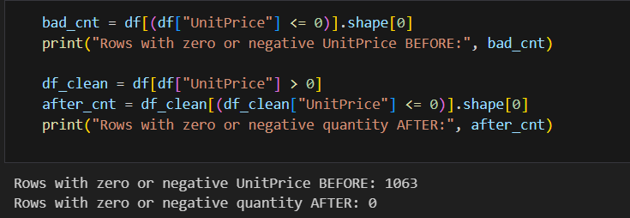
- Removed cancelled purchases:

- Removing invalid stock codes and normalizing descriptions:
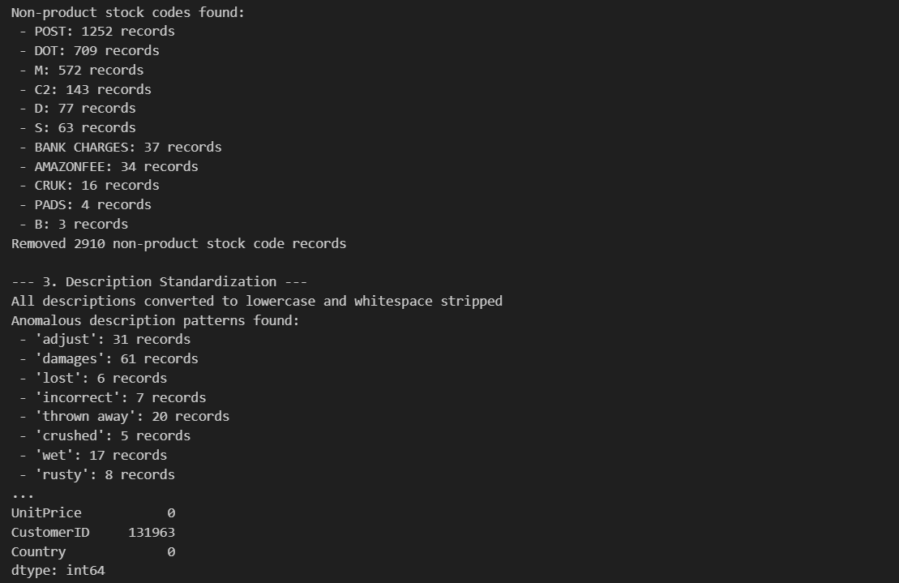

Data Type Conversion
Converted the type of invoice date to python dateTime data type:
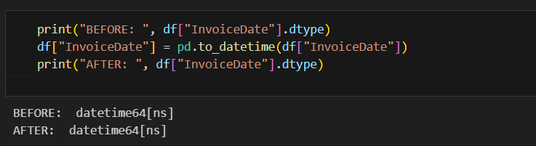
Feature Engineering
Created a new column in the data frame called “TotalAmount” which is the product of the 2 columns of UnitPrice and Quantity to find the total amount gained from a purchased product.
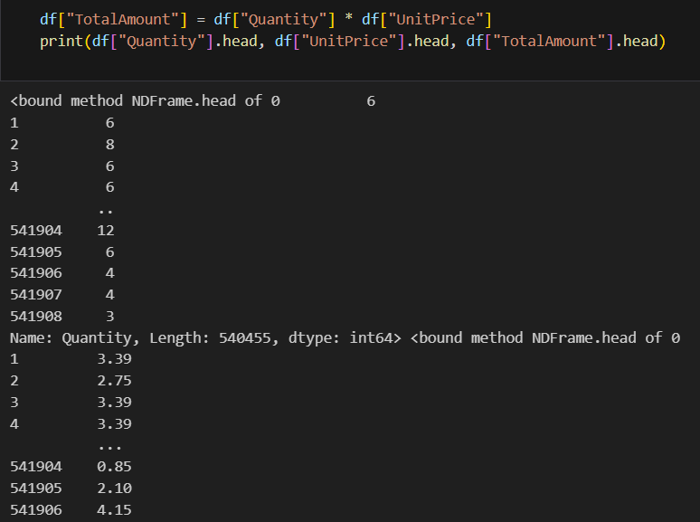

Grouping data points by the attribute “InvoiceNo” to keep track of all product items that were purchased together; the information gained from this grouping will be further used to find the frequent item sets.
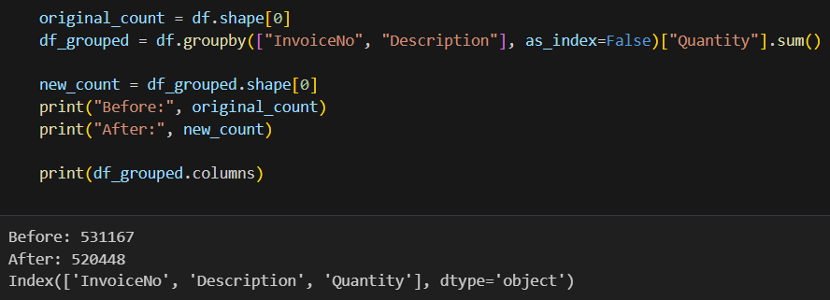

Removed the products with sell counts < 10 to keep track of valuable and frequent products only.
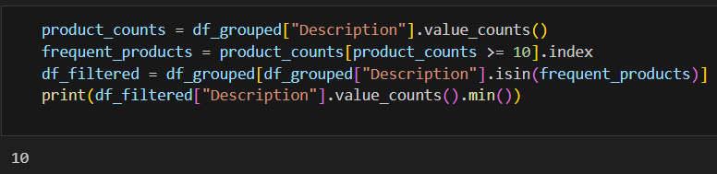

Preprocessing for Association Rule Mining
Creating baskets from the grouped attributes to start with the association rule mining process:
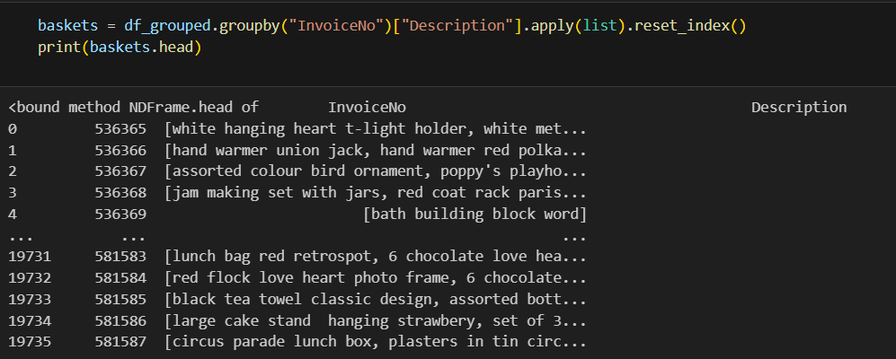

EDA for Association Rules
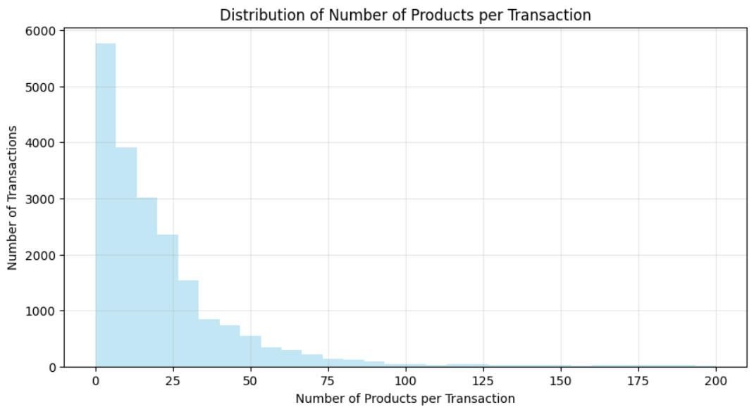
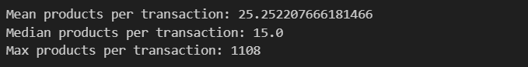

Plotting the top 15 most frequent items:
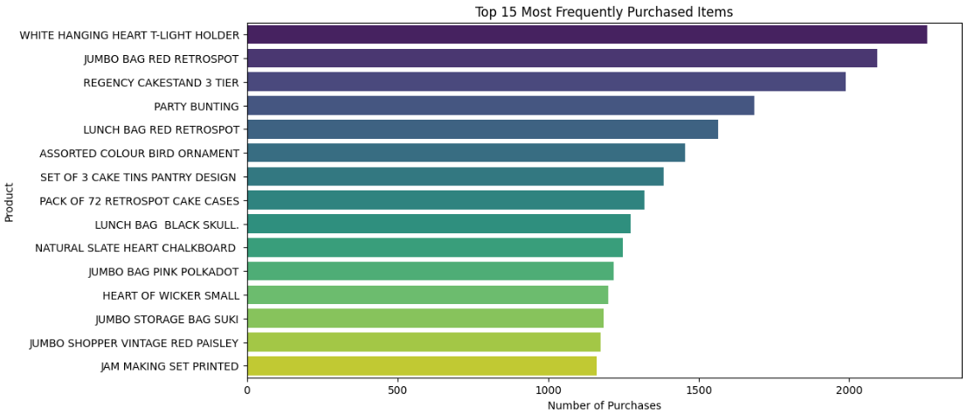

Distribution of UnitPrice:
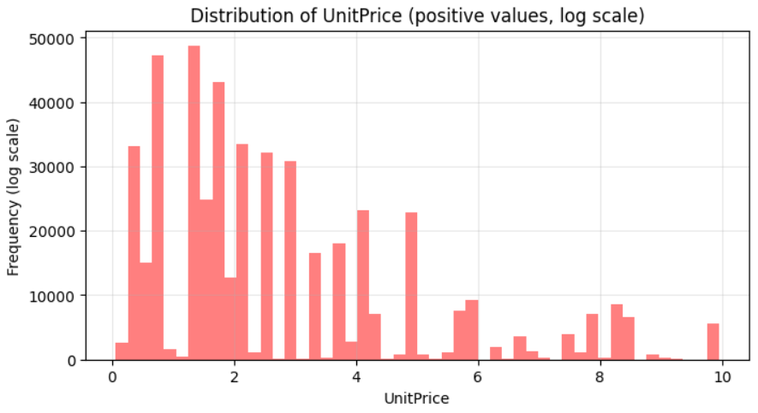
The distribution is rather skewed which makes sense because items with lower prices have been bought more than the expensive ones.
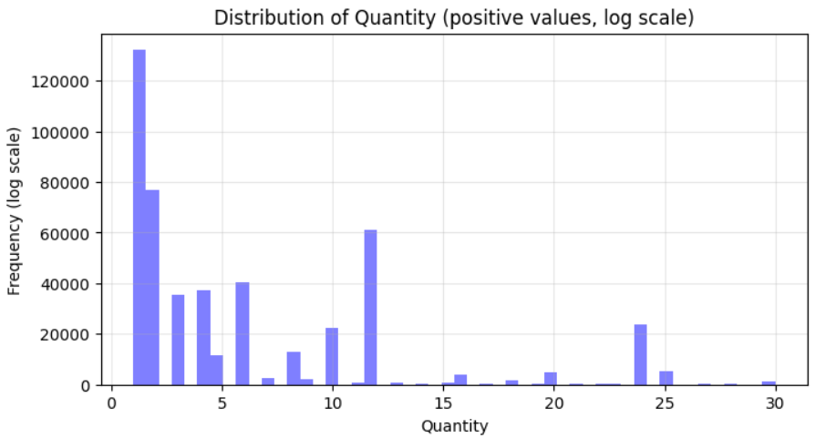
The distribution of quantity is rather skewed.

Association Rule Mining
First, we find all possible rules through Apriori algorithm:
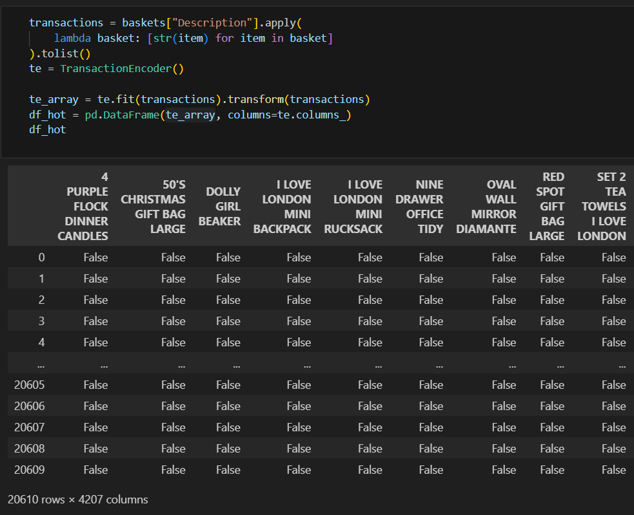
I tried various values for support, confidence, and lift thresholds:
Support:
The value of support will be later chosen from [0.01, 0.03) as 0.03 is the largest support that provides more than 10 rules.
  - 3200
  - 180
  - 18
Confidence:
0.5 841
0.6 503
0.7 265
0.8 105
0.9 20
The confidence threshold will be later chosen from [0.5, 0.9).
Lift:
I picked the lift threshold as 1 since lift > 1 means that the items are correlated with each other.
The lift values are quite high and since the data matrix is sparse, it rings a bell that there is a possibility that the dataset is full of null transactions and since lift is sensitive to such transactions, it can mislead us. Therefore, I will consider some other measure to verify the rules’ interestingness later.
I added more measures to the rules data frame below, such as kulc and imbalance ratio and try to filter out some using these measures’ thresholds.
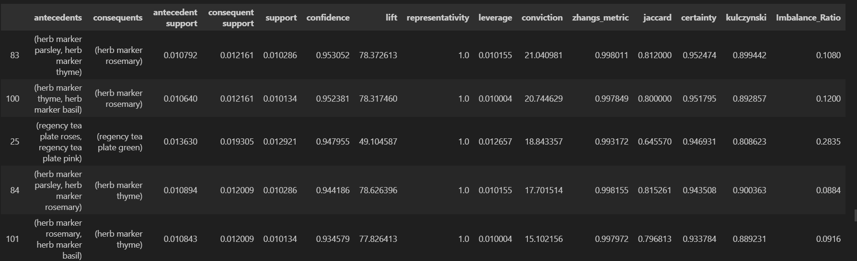
Filtering rules:
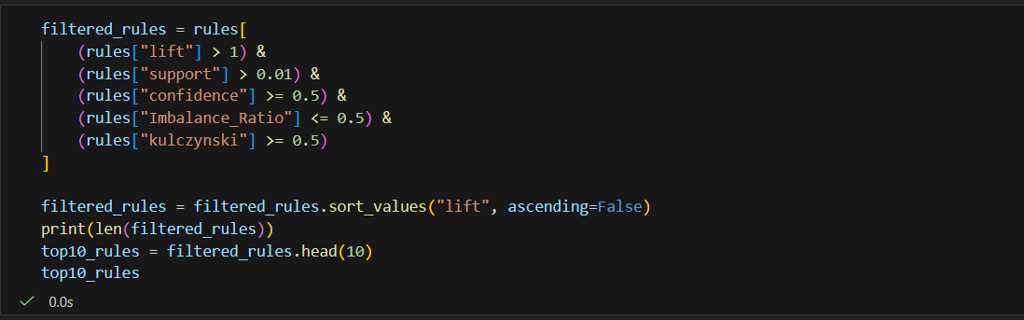
I fined tuned the threshold values to ensure all of them are considered as well as the fact that the number of resulting rules reaches the minimum of 10.
I chose the kulc threshold as 0.5 since less values of kulc mean that the rule is not reliable enough and the 2 items are not much correlated.
Moreover, I chose the threshold of 0.59 for imbalance ratio to ensure that the correlation between rules’ items is not one-sided.
Final 10 rules:
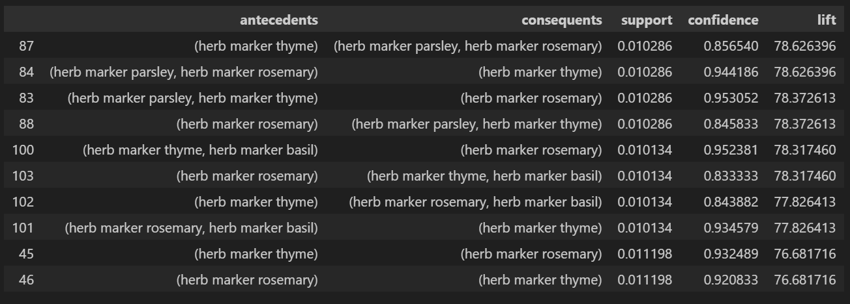
The shape of the scatter plot of rules before and after filtering:
Before:
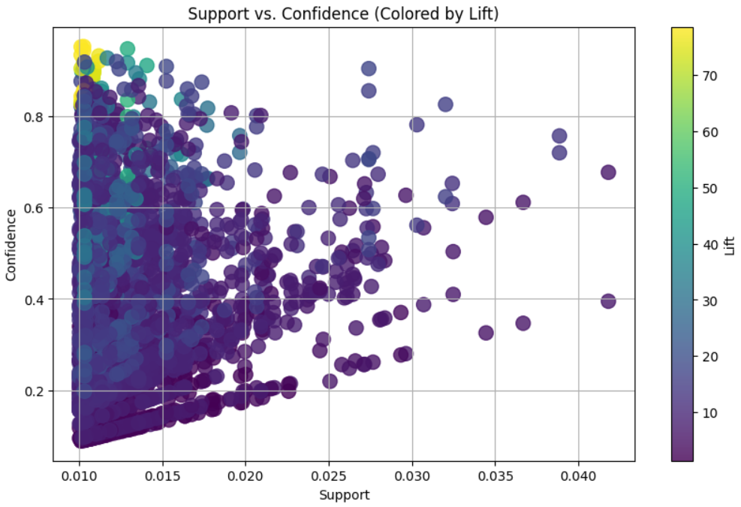

After:
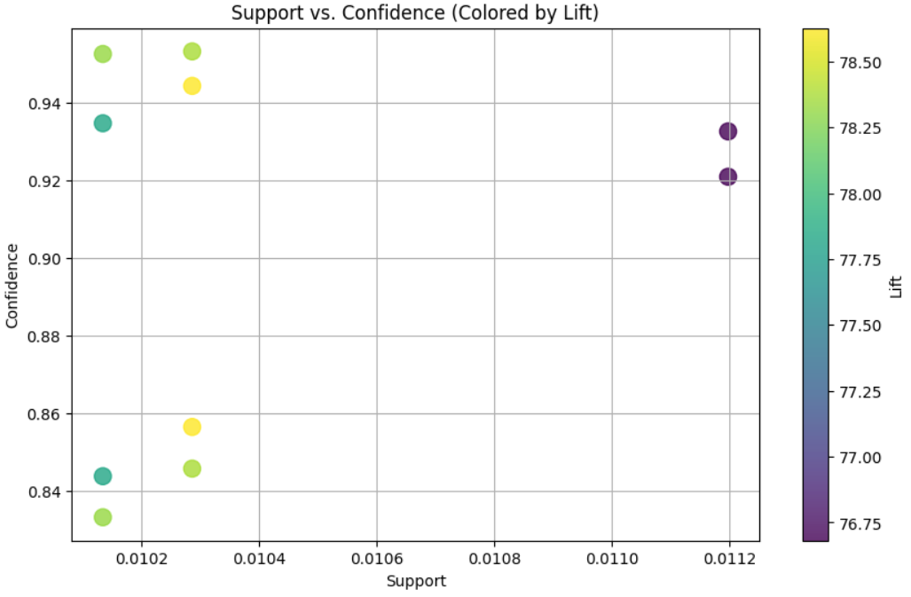
As can be seen clearly, the axis of the plot has changed and the higher values of each of the measures have survived which is quite desired and a satisfactory.
Top 5 Rules
I designed a formula and weighted each of the required measures (support, confidence, and lift) to ensure all of them contribute to the very last selection:
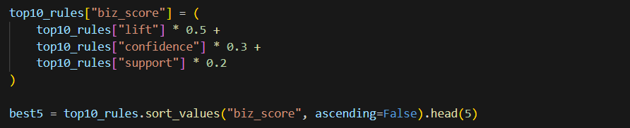

Final 5 rules:
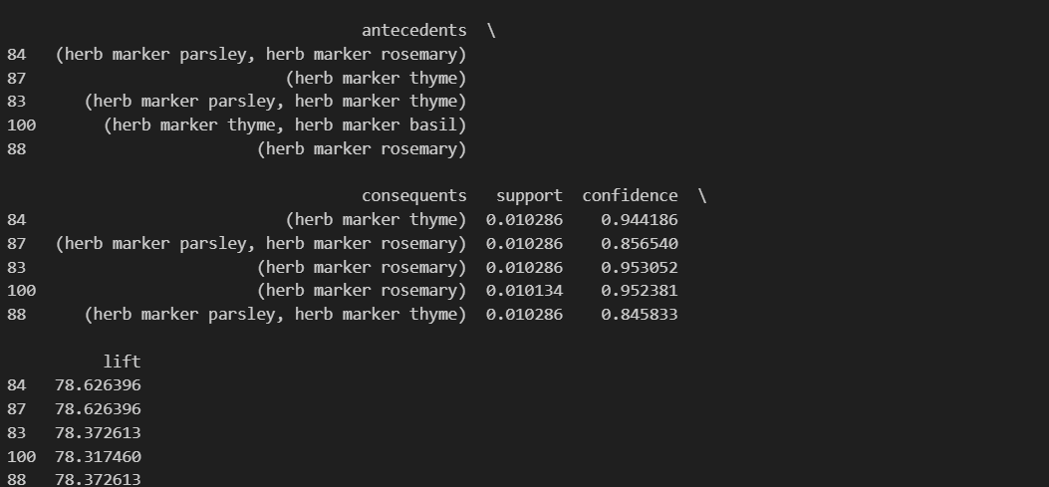

Time Series Analysis
First, I grouped the daily sales:
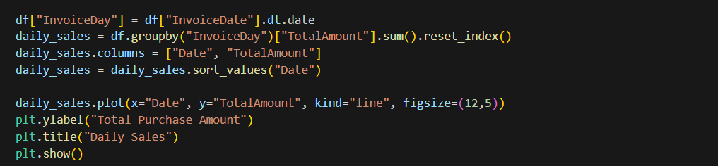
And then plotted the daily sales in a chronological order:
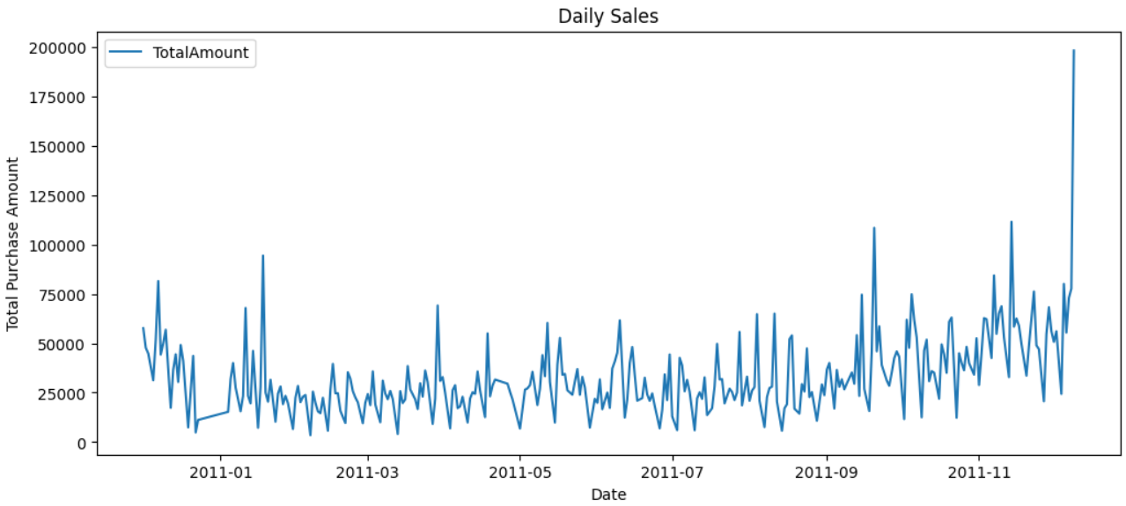
As can be seen there are a lot of fluctuations in the daily sales, however, they are going to be smoothed out using simple moving average method in the next step.
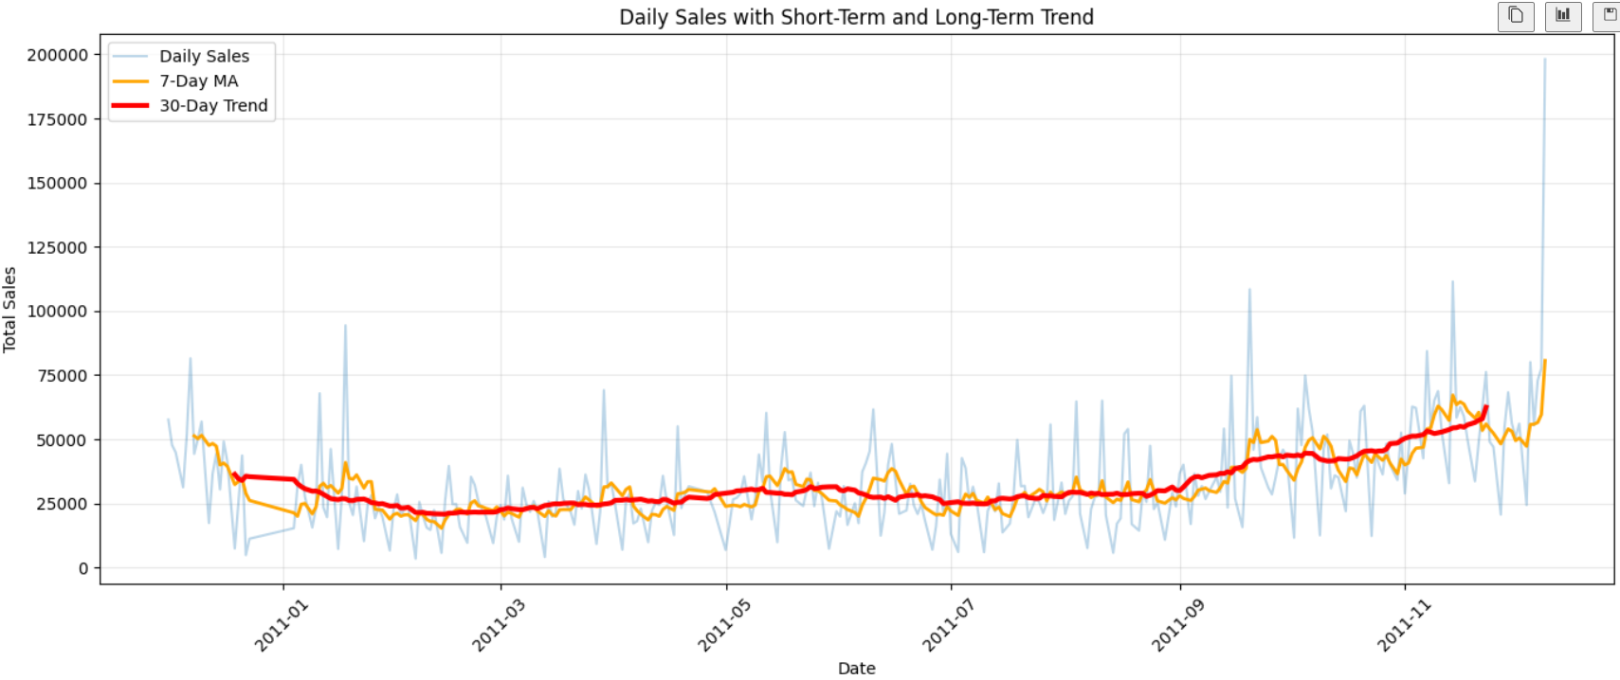
I plotted 2 moving average lines with lengths of 7 and 30 and as expected the more the SMA parameter increases, the smoother the line becomes.

Time Series Forecasting
Splitting train and test data:
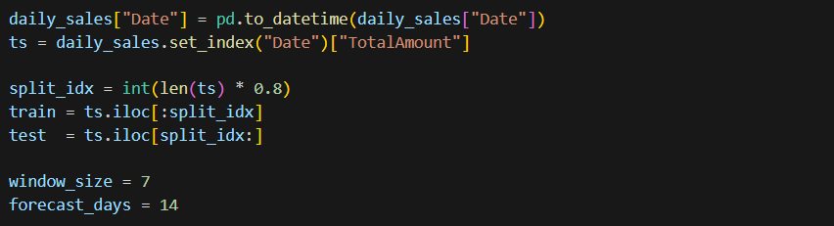
I applied SMA as the forecasting method; the green dashed line shows the prediction:
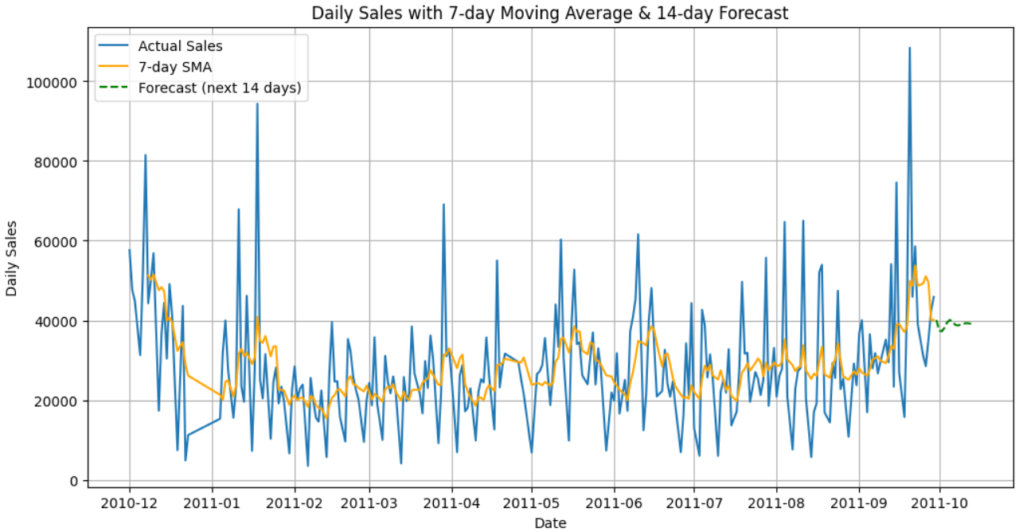

Verifying the method using the test data
Important note:
There are 2 cases of prediction generations using SMA method; at each timestamp there are 2 possibilities: adding the predicted value to the window or replacing the actual value.
The point is that MA is a smoothing method and after 2 iterations of window size it completely flattens. However, replacing the actual values avoids that kind of flattening and improves accuracy a little bit. Below comes both cases and as can be seen in the case of no replacement, the method made more realistic predictions.
Testing without adding the actual data:
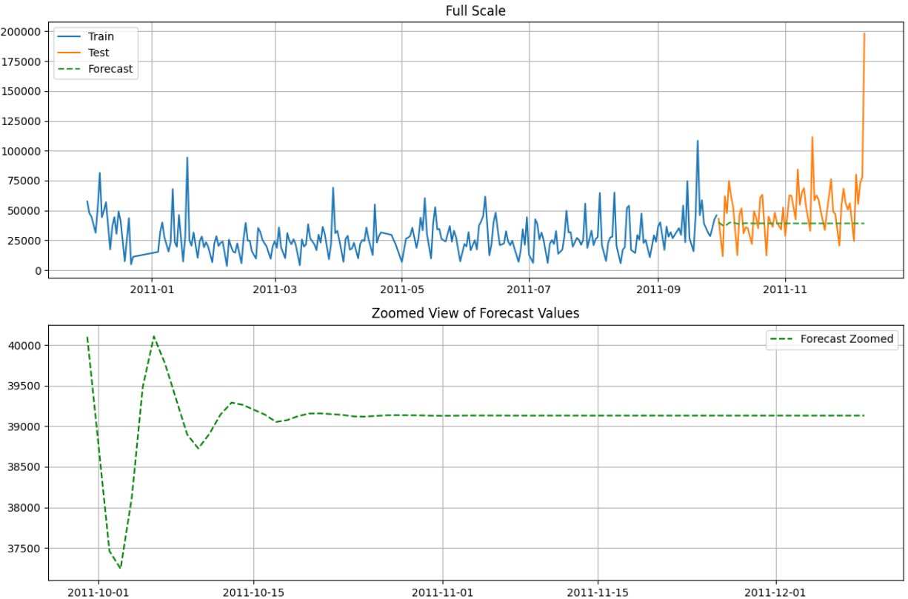
Testing with the actual data:
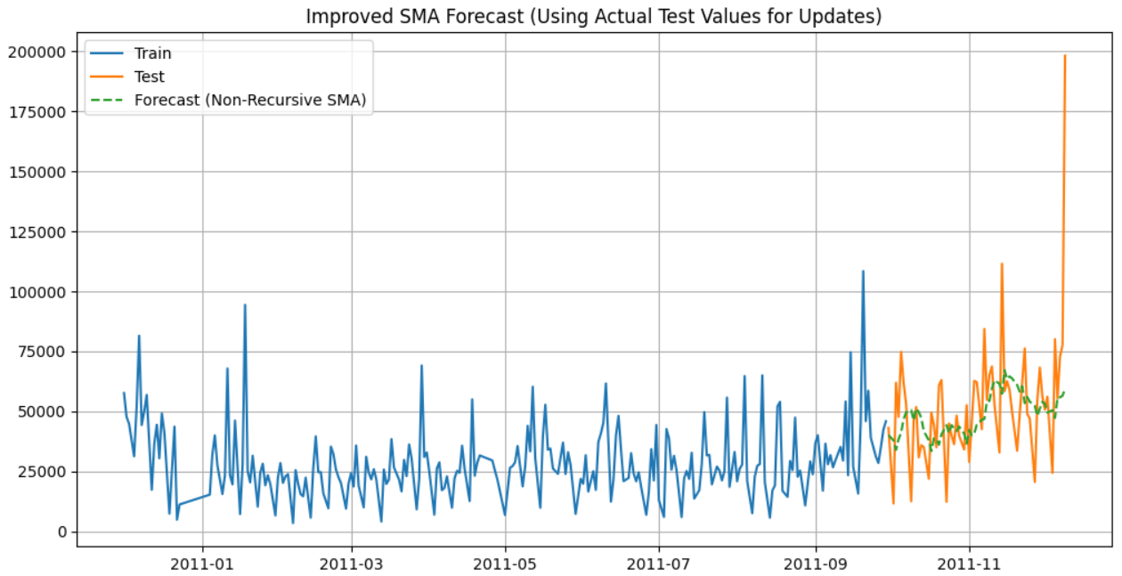
The error measures of the 2 approaches are quite expected as after adding the actual data points the error measures have decreased.

Analysis and Interpretation
SMA is one of the least reliable forecasting methods for anything beyond very short-term prediction and the flattening we observed is exactly why.
Reason 1: SMA cannot model trend
If data is trending upward or downward:
SMA smooths it out, forecast stays “in the middle” and completely misses the trend

Reason 2: SMA cannot model seasonality
If sales have weekly patterns (Mon–Sun cycle), SMA ignores this.
Reason 3: Recursive SMA always collapses to a constant
Recursive forecasting means:
Predict tomorrow using today's forecast, Predict next day using today's predicted value

Evaluation Metrics:
MAE = (1/n) Σ(i=1 to n) |y_i – ŷ_i|
mean squared error (MSE), the average squared difference between the value observed in a statistical study and the values predicted from a model.
It provides an estimate of the size of the inaccuracy, but not its direction (e.g., over or under-prediction).
Resiliency to outliers. The MAE is not as impacted by extreme results as other metrics, such as Mean Squared Error (MSE), are. This makes it an appropriate measure for datasets that include outliers or extreme values.

RMSE = sqrt [(Σ(Pi – Oi)²) / n]
It is one of the standard ways to measure the error rate of a model in predicting quantitative data.
It is a metric predominantly utilized in regression analysis and forecasting, where accuracy matters significantly. The lower the RMSE, the better the model’s ability to predict accurately. Conversely, a higher RMSE signifies a greater discrepancy between the predicted and actual outcomes.

MAPE
Mean absolute percentage error measures the average magnitude of error produced by a model, or how far off predictions are on average. A MAPE value of 20% means that the average absolute percentage difference between the predictions and the actuals is 20%
MAPE=n1​∑ (​∣Actual_i​ − Forecast_i​∣ / ​Actual_i ) ​×100

